# PROBLEM STATEMENT

Swine production is a major agricultural enterprise in Quebec and the environmental effects of swine manure storage systems and application methods are a concern. The biggest environmental concern with respect to swine manure is currently surface and ground water quality and phosphorus runoff which is responsible of the current eutrophication of Quebec’s water systems.

The issue of swine manure is becoming an issue of point source production, especially as it relates to livestock ownership and responsibility for the collected material.

Since much of the province’s swine manure can be collected, stored, and spread on the land surface, this manure can be used as a substantial nutrient source for crops. Swine manure is handled as solid, semi‐solid slurry, or liquid, depending on the type of housing and manure handling system used. Each of these systems has some unique features that add complexity to the manure handling, transportation and use (Kofoed, A.D. et al, 1986).

One drawback of the traditional use of manure is that land for application is physically limited and is also restricted by the Ministry. Therefore, at a certain farm‐site, manure produced must often be stored and cannot be used to its full extent.

As of today, swine production units are not geared toward retaining nutrients in swine manure. However, several techniques of volume reduction of manure and concentration of nutrients contained in manure have been developed by decreasing its water content. Thus, the cost of storage and amount of spreading on land can be reduced without a significant loss of the nutrients important for the growth of plants, especially nitrogen and phosphorous compounds. Also, the water taken out of the manure can be reused on farm for cleaning and watering purposes, therefore, limiting water consumption by recycling water and the associated cost of water consumption. The use of manure as a fertilizer as opposed to regular inorganic fertilizers is also a great way to reduce the energy consumption of fertilizer manufacture. Combine to other agricultural industries, fertilizer manufactures energy consumption accounts for up to 3% of Canada’s total commercial fossil fuels consumption (McLaughlin, N.B, 2000).

An integrated manure management system adapted to the specific needs of a farm‐site could be an interesting approach to use manure at its maximum potential, in the most efficient way and by limiting its negative impacts on the environment without compromising its fertilizing value.

# 

# Objectives and Scope

The main objective of this project is to design a farm scale system aimed at improving the use of manure on the farm and at reducing the quantity of waste at the same time.

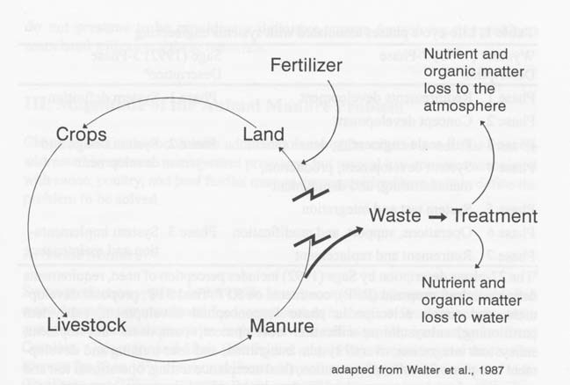This system will help to enhance the manure value of today’s farm industries. The designed system will be used to close the loop opened by the use of inorganic fertilizers by recovering the resource value of the manure.

Figure 1 ‐ Separation of animal and crop production enterprise and the resultant animal waste and soil quality problems.

In order to create a semi closed system, we also took into consideration the other aspect of the farm:

‐ food production (we focused only on corn)

* Soil requirements and fertilizing applications
* Hog‐farming techniques and process
* Manure handling, storage and possibility of a new manure treatment to concentrate the nutrients in the manure.

Subsequently, the size of the different parts of this system, the quantity of manure produced each year and the size of the different manure tanks, the composting type and area and the scale up of the integrated farm system will be evaluated.

Finally, the integrated farm system along with the use of the reverse osmosis technology will be economically and environmentally evaluated. The approximate budget for the equipment, buildings and operations required for the implementation of this farm‐system will be calculated and compared to conventional hog farms. The advantages, benefits and feasibility of the system will be assessed and discussed.

METHODOLOGY

### The design approach

Throughout the entire engineering design process, environmental and economic requirements and implications associated with all possible design will be addressed to conceptualize and develop the best possible design. Ultimately, tradeoffs among alternatives will be examined and decisions made.

When livestock production enterprises are being separated from crop production enterprises, retention of nutrient in the manure is often not an important goal for large swine production units. Also, the amount of land available for manure application is often limited. Consequently, loss of nutrients to the environment may be encouraged to reduce the quantity of manure that must be handled. With a holistic approach to the manure management practice, the production system would take into consideration each of these parameters and therefore enhance the fertilizing value of the manure.

In general, it requires fewer acres to balance the available manure nutrients for the farm’s nitrogen needs. However, applying manure nutrients at the nitrogen needs rate generally over applies P2O5 by two to four times the crop needs. This poses an environmental risk due to the high application of P2O5 at one time and the buildup of phosphorus in the soil. Also, applying manure nutrients at their optimal nitrogen needs level can very rapidly increase potassium levels in soil, which can contribute to animal‐health problems (Masse, L. et al., 2007).

A farm can sustain itself for a short time by balancing for nitrogen. However, this will significantly increase phosphorus and potassium levels in the soil. The goal of our integrated manure management system is to operate a livestock enterprise in a manner that can sustain the cycling of manure nutrients indefinitely while minimizing the risk of nitrogen and phosphorus leaching and runoff.

## Farm sizing

The context of this project will be defined by a medium‐size growing‐finishing swine farm located in Saint‐Etienne de Beauharnois, Quebec.

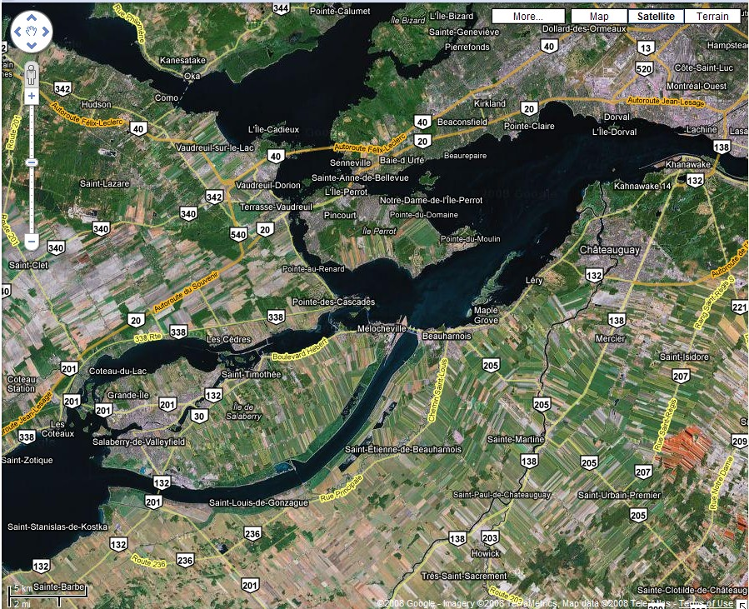

Figure 10 –Location of St‐Étienne de Beauharnois

We chose this area because the type of soil and fertilizing requirements of land are known and also that there is little opportunity for manure gathering from other producers in that region. The cultivated lands of our design system will be based on the case study of the **Jacques Leduc et fils inc. Farm**. It is a cash crop farm with a size of approximately 535 hectares (1322 acres). The type of soil is mainly Ste‐Rosalie clay, which is rich in potassium. After talking with Patrick Leduc, head‐agronomist in Quebec for Pioneer, the fertilization requirements for inorganic chemical fertilizers were determined to be 190kg of nitrogen (N) per hectare, 85 kg of phosphorus (P2O5) per hectare and no input of potassium (K2O) required.

For the purpose of the design project, we will focus only on the production of corn. However, the cultivated lands work under crop rotation of corn and soybean based on a three years period. This mean that on a same field, during two consecutive years, they cultivate corn and the third year, this field is under soybean.

We will suppose that in the swine facility unit, there is no bedding involved and that pigs rest on slatted floor. Also, we will presume that the swine farm manure management system consists of a solid‐liquid belt separation system with an efficiency to separate the manure in approximately 60% solid, 40% liquid.

## Estimating Quantity of manure produced and its nutrient content

The first step of the design of the integrated manure management system is to determine the quantity of manure produced on the farm and the manure nutrient content. In order to do so, a manure analysis will be conducted to calculate information on the amount of nitrogen, phosphorus, and potassium available in the manure.

The manure analysis of the farm system will be conducted using the American Society of Agricultural Engineers standard tables included in annexes. In order to have a good estimate of the manure nutrients available on the farming operation, we will:

‐ Estimate manure and nutrient production for each animal type

‐ Add the nutrient amounts for each animal type

‐ Add the nutrient amounts for each animal

Also, knowing the manure load of the farm, we will calculate the size and specifications of the manure storage pit. We will try to follow the nutrients content throughout the design to minimize the losses to the environment.

## Estimating Crop Nutrient Needs

The next step is to determine the farm’s crop nutrient needs. This highly depends on the type of soil and type of crop grown on the farm. However, some theoretical values of the recommended amount of nutrients per crop are available in literature. When consulting these, we can calculate the nutrient required by the crops to be grown on our case study farm and compare it to the nutrient content of the manure.

## Evaluation of the farm system Nutrient Balance

The third step is to estimate the farm nutrient balance. It involves measuring or estimating total manure nutrient production compared to whole farm crop nutrient utilization. It can easily be done using this equation:

Manure Nutrient Inputs – Crop Nutrient Needs = Losses to Environment

The loss to environment is the difference between the inputs and the managed outputs. This imbalance accounts for both the direct environmental loss and the accumulation of nutrients in the soil. In our design system, manure nutrients are recycled for crop production. The goal of the design is to achieve a balance of inputs with managed nutrient outputs a on the farm itself.